*This document is a mock News Release for a class assignment*

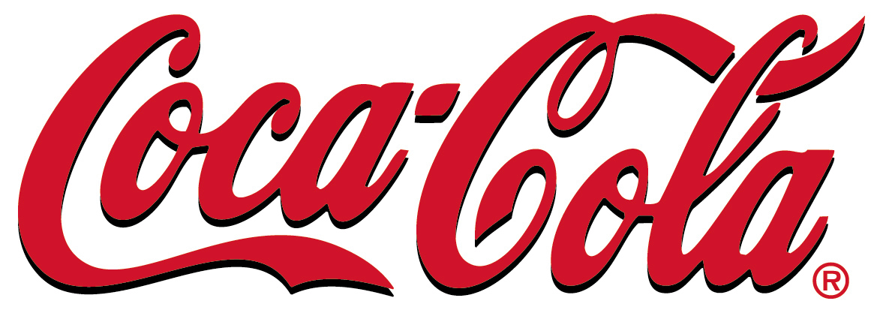
Coca-Cola Company Heather Schwartz
Atlanta, GA Schwartzhs@cocacola.com
(404) 676-2121 (404)684-2476

Coca-Cola is having a News Conference in regards to the Polar Bear Support Fund

WHAT:
Coca-Cola and the World Wildlife Fund have teamed together to create the Coca-Cola Company Polar Bear Support Fund to help build awareness and support for polar bears through adoption and donation. Coca-Cola will holding a press conference in 309 Heide Hall regarding the Polar Bear Support Fund along with a member of the World Wildlife Fund and guest speaker Jessica Alba, who is an avid supporter.

WHERE:
Room 309 is located on the third floor of Heide Hall directly next to Winther Hall. The two entrances are located off Prairie St. in Whitewater, Wis.

WHEN:
Tuesday, December 21, 2010 starting at 10 a.m.
WHO:
Coca-Cola Company is a worldwide leader in beverage distribution. The Coca-Cola Company has been in business for 124 years providing over 3,000 different beverages. Coke has teamed up with the World Wildlife Fund to create the Polar Bear Support Fund. The World Wildlife Fund is the world’s leading conservation organization which strives to protect the future of nature in over 100 different countries.

WHY:
Current climate trends are causing devastation to polar bears’ habitats and the species itself. There are a mere 22,000 polar bears left in the Arctic, which is equivalent to filling half of Miller Park. Since 2007,
Coca-Cola has contributed $500,000 to World Wildlife Fund to help in its efforts; an additional $100,000 was raised through the MyCokeRewards brand loyalty program. This fund is to build awareness of the inevitable tragedies these polar bears will face if we don’t make a change.

